**STARFLEET SCIENCES**

**TRAINING RECORD: INTRO TRAINING**

**INTRO TO PLANETARY SCIENCES**





**Name:**

**Subjects Required:**

**SCC:**

**Date Completed:**

**STARFLEET ACADEMY**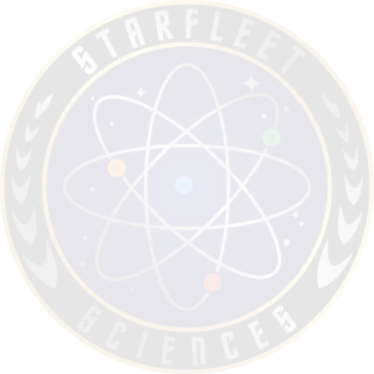

**INSTITUTE OF SCIENCES (IOSC)**

**College of Ecology**

ECOL 101: History of Ecology Part 1

ECOL 102: History of Ecology Part 2

ECOL 103: History of Ecology Part 3

**College of Mathematics**

MATH 101: Early History to 1600

MATH 102: History from 1600 to Present

**College of Microorganisms**

MOO 101: History of Microorganisms

**College of Oceanography**



COCN 101: Intro to Oceanography Part 1



COCN 102: Intro to Oceanography Part 2

**College of Physics**

CP 101: Introduction to Physics Part 1



CP 102: Introduction to Physics Part 2



CP 103; Introduction to Physics Part 2

Completed Training Records and evidence of completion of subjects (certificates or screenshots) should be emailed to: [sfsci-chiefedu@sfi.org](mailto:sfsci-chiefedu@sfi.org)

For use by SFSciences Staff only

Date received:

Date processed:

An important note about submitting courses to Starfleet Academy

When completing multiple courses from the same College, the maximum number of courses you can have submitted at one time is ten (10). That means that you need to wait for the Director of that College to enter your grades into the SFI database (https://db.sfi.org/) before you are allowed to submit another ten (10) courses. This is to ensure that Starfleet Academy Directors are not overwhelmed.